**Assignment Day day_2**

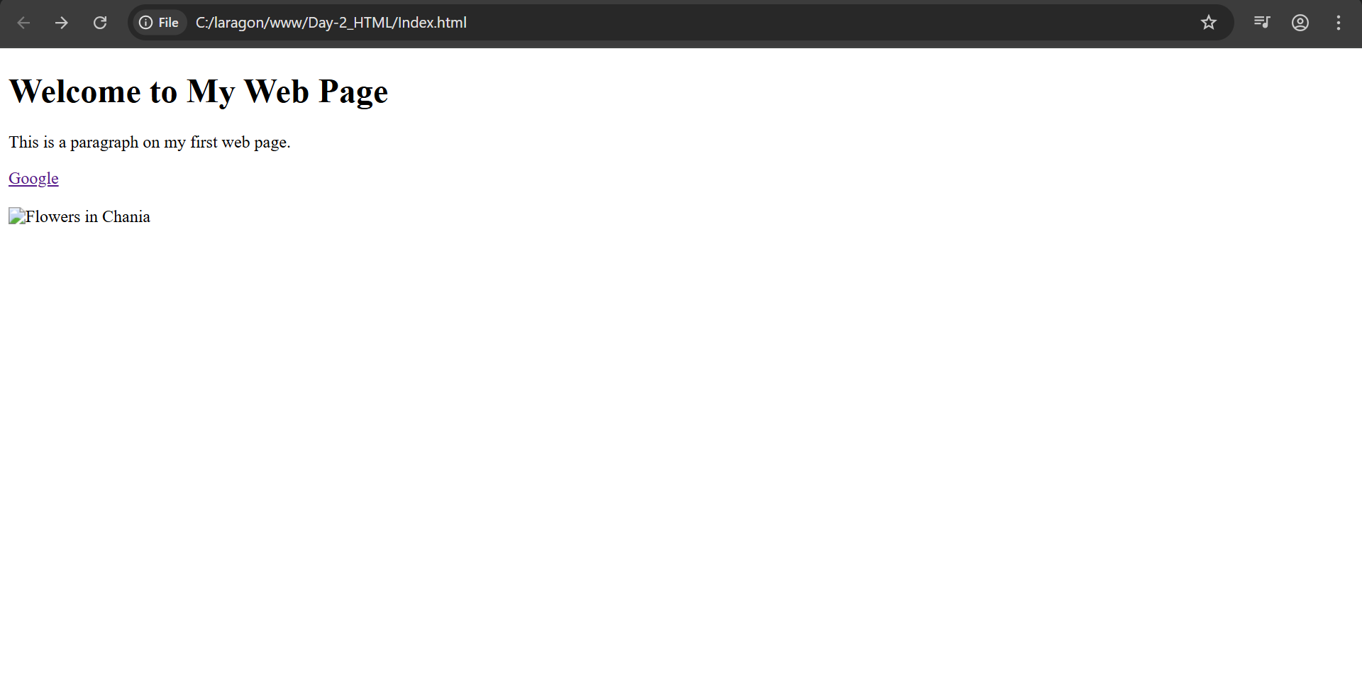

I have created a HTML code of a simple web page titled "My First Web Page". It begins with a level-one heading that welcomes visitors to the page. Below the heading, there is a paragraph that briefly describes the content of the web page. A hyperlink is included that directs users to the Google homepage when clicked. After the link, two line breaks are used to create some vertical space. Finally, the page attempts to display an image with the file name "wrongname.gif". If the image is not found, the alternate text "Flowers in Chania" will be shown instead.